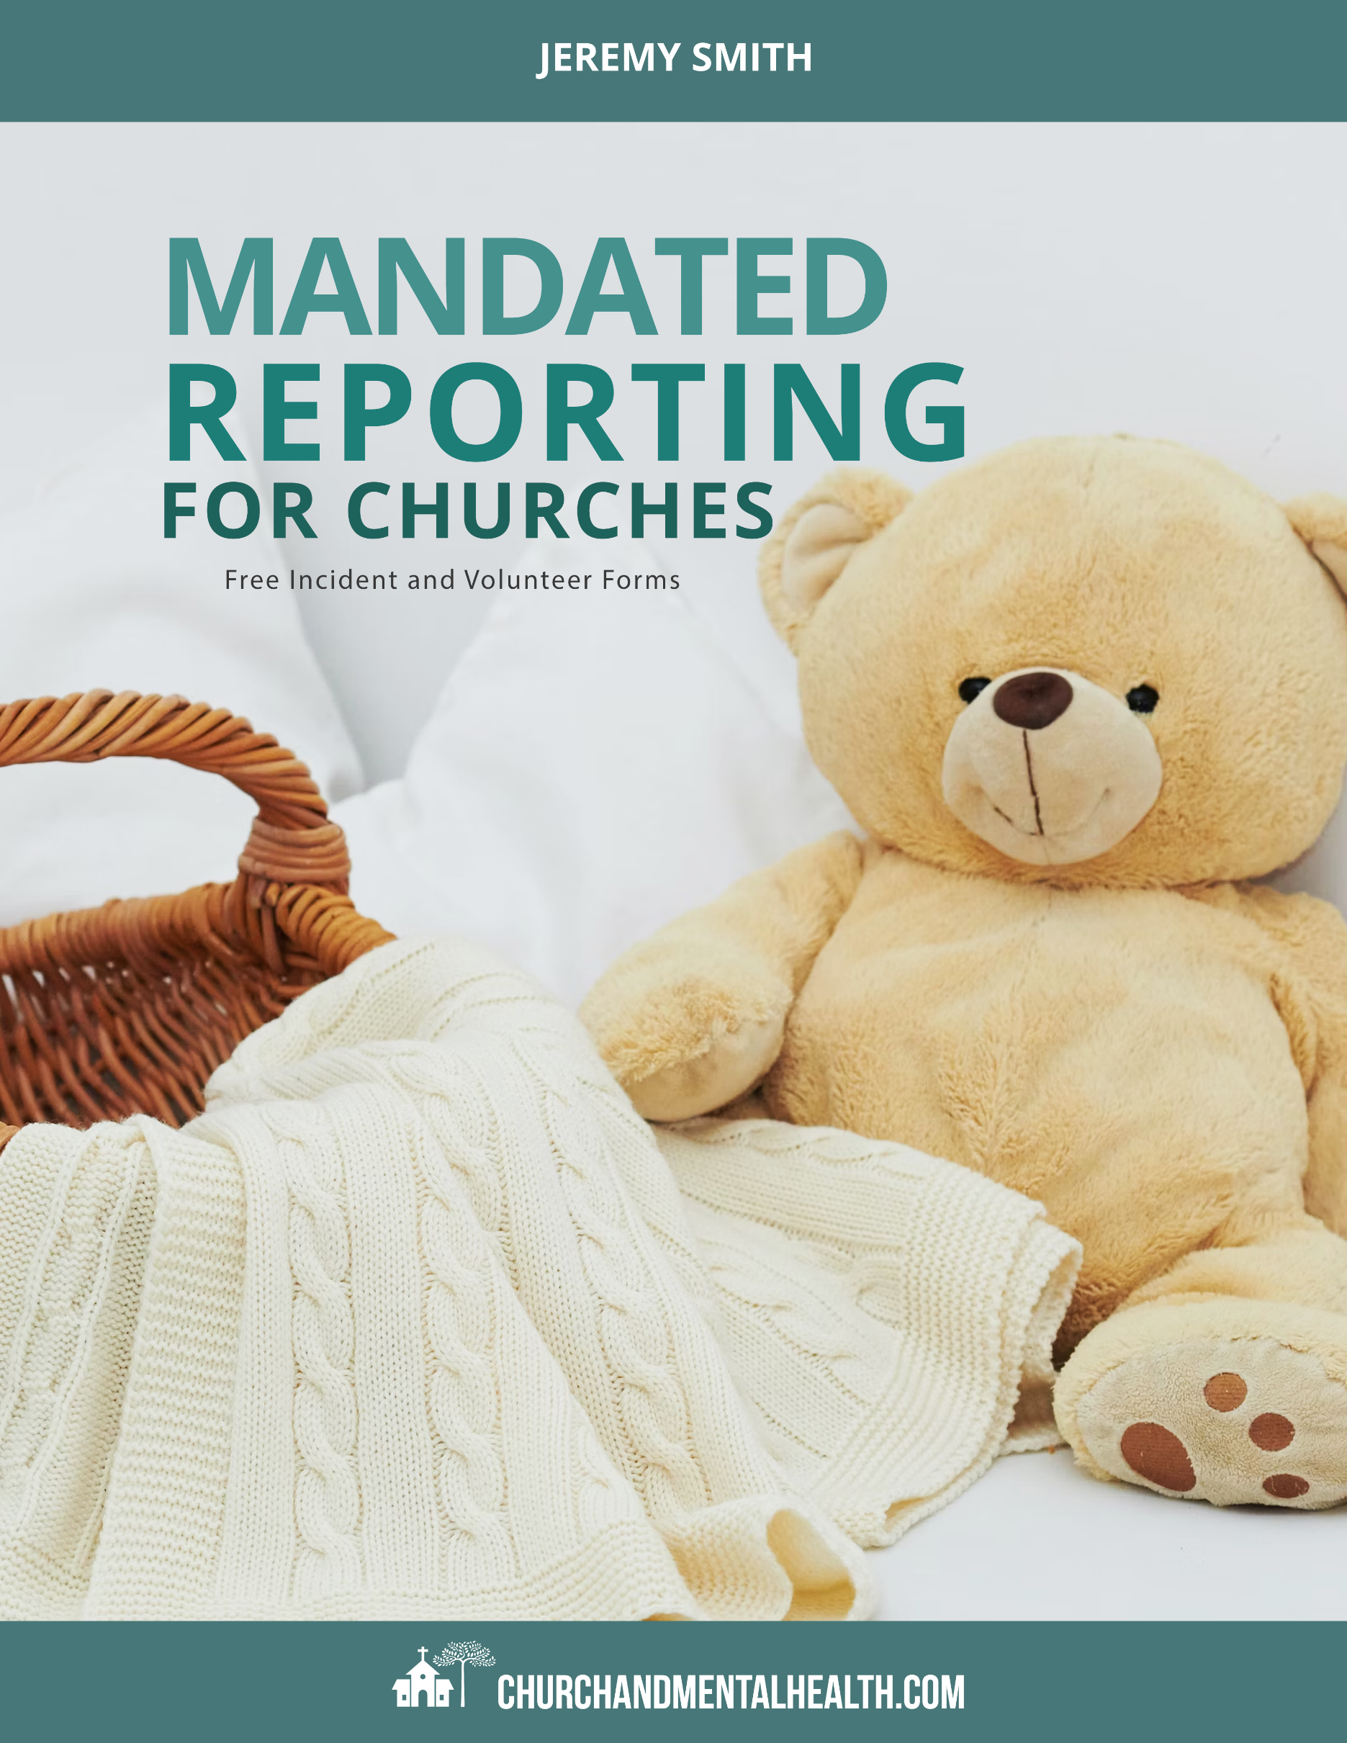

The forms below are provided free of charge for churches or pastors to use. We have made them editable in Word so you can use your own branding as well as put in the correct state mandating reporting codes into the proper areas. Below, we will specifically note what you need to do so that your forms are appropriate for your U.S. state's code.

*(If you live outside the United States and need help, shoot us an email at* [*jeremy@churchandmentalhealth.com*](mailto:jeremy@churchandmentalhealth.com) *and we will be happy to assist however we can.)*

Before we edit the forms, do note this is the free companion resource to the main ebook that goes into the details to help your church or ministry with having a crash course on mandated reporting and how to help set up your church volunteers for success. This document does not have that.

We encourage you to go get Mandated Reporting for Churches first and read through it first. When you have completed it, use the steps below to make these forms custom to your ministry. You can get the ebook here: <https://churchandmentalhealth.com/product/mandatory-reporting-for-churches>

For the forms below, here are the changes you need to make:

1. **Checklist for Mandatory Report Incident Report.**Some churches want to use this form for a complete incident form, not just about child abuse. This may include calling the police, vandalism, removing drugs, or an accident. Edit the checklist as you please. We suggest leaving all five options currently there as over-reporting is much better than under-reporting.
2. **Church/Ministry Name on Volunteer Form.**The first line of the first paragraph has a place to put your church or ministry name. Some churches also have a single designation for mandatory reporting they also want to put the name and phone number there. I don't recommend this as churches tend to not redo this form if a pastor leaves or changes position or is big enough to have multiple people. Simply make that a training issue.
3. **State Code on Mandated Reporting on Volunteer Form.**The template shows the Ohio Revised Code on mandated reporting to educate volunteers on what pastors are held to. To make this relevant for your church, visit www.com and copy/paste the code into this form for volunteers to review.
4. **Review These Forms Regularly.**  
   We highly encourage whoever oversees these forms to review what has changed with mandated reporting every 3-6 months. Sometimes nothing changes for years and sometimes it changes three times in one year. This is important to keep on top of. Use that same state reporting code to verify if there are any changes.

**Mandated Reporter Incident Report**

Date of Incident: ___________________________ Date of Report: ___________________________

Check the incident type you are reporting:

* Child Abuse/Neglect
* Elderly Abuse/Neglect
* Suicidal Behavior
* Homicidal Behavior
* Animal Abuse

|  |  |  |  |  |  |
| --- | --- | --- | --- | --- | --- |
| **Name**  **(List all involved)** | **V= Victim?**  **P = Perpetrator?**  **W = Witness?**  **O = Other?** | **Gender** | **Age or Birthdate** | **Address**  **(if applicable)** | |
| 1. |  |  |  |  | |
| 2. |  |  |  |  | |
| 3. |  |  |  |  | |
| 4. |  |  |  |  | |
| **Briefly, but completely, explain what happened. Who was involved? What was said/done? What was witnessed by you or others? How did it end? What actions were taken by staff?** | | | | | |
|  | | | | | |
|  | | | | | |
|  | | | | | |
|  | | | | | |
|  | | | | | |
|  | | | | | |
|  | | | | | |
| Staff Signature | | | | | Date: |
| Supervisor Signature: | | | | | Date: |

**Volunteer Understanding of Mandated Reporting**

Date of Training: ___________________________

I, ___________________, in agreeing to volunteer alongside (Your Church Name) that I have read and understand the mandated reporting policies of the church as well as those laid out within Ohio Revised Code 2151.421(A)(4)(a)

“No cleric and no person, other than a volunteer, designated by any church, religious society, or faith acting as a leader, official, or delegate on behalf of the church, religious society, or faith who is acting in an official or professional capacity, who knows, or has reasonable cause to believe based on facts that would cause a reasonable person in a similar position to believe, that a child under eighteen years of age or a mentally retarded, developmentally disabled, or physically impaired child under twenty-one years of age has suffered or faces a threat of suffering any physical or mental wound, injury, disability, or condition of a nature that reasonably indicates abuse or neglect of the child, and who knows, or has reasonable cause to believe based on facts that would cause a reasonable person in a similar position to believe, that another cleric or another person, other than a volunteer, designated by a church, religious society, or faith acting as a leader, official, or delegate on behalf of the church, religious society, or faith caused, or poses the threat of causing, the wound, injury, disability, or condition that reasonably indicates abuse or neglect shall fail to immediately report that knowledge or reasonable cause to believe to the entity or persons specified in this division.”

This form is signed below in agreement that this volunteer will immediately communicate any suspected or observed physical, emotional, or sexual abuse to a child or elderly person to a mandated reporting pastor at that event. Any concerns of the negligence of supervision or training regarding mandated reporting will also be immediately communicated to that pastor or their supervising pastor.

|  |  |
| --- | --- |
| Staff Signature | Date: |
| Supervisor Signature: | Date: |